Me llamo___________________________ Fecha________________________
U3.5: ¡Vamos de compras!
- Choose the item in each group that does not belong. The first one has been done for you.
- vender regatear ropa interior gastar
- botas sandalias zapatos traje
- pagar llevar hacer juego usar
- mercado tienda almacén cartera
- abrigo suéter corbata chaqueta
- jeans bolsa falda pantalones
- camisa camiseta blusa botas
- mercado sombrero centro comercial almacén

- En la tienda
Define the clothes and give the color in Spanish. ¡OJO! Adjectives agree in gender and number. Ex. The yellow shoes: Los zapatos amarillos (both masculine and plural)
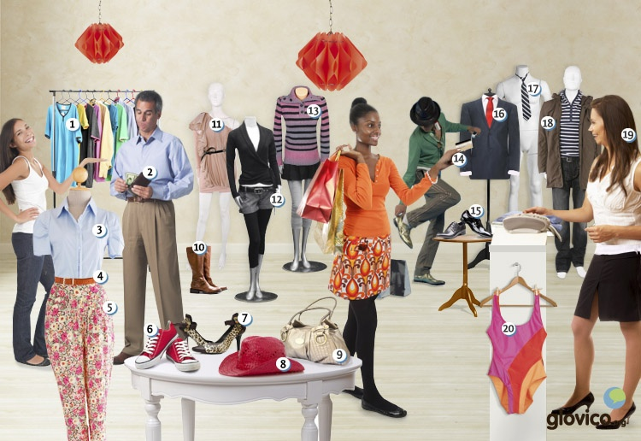

1.
2.
3.
4
5.
6.
7.
8.
9.
10.
11.
12.
13.
14.
15.
16.
17.
18.
19.
20.
- Imagine that you and your family are going on vacation with a classmate’s family. Decide where you are going, and draw or find a picture of two suitcases (You can use Google Draw). Write in each suitcase a list of clothing that each of you would take on vacation, and answer the following questions.
¿Adónde van?
¿Qué tiempo va a hacer allí?
¿Qué van a hacer allí?
¿Qué hay en sus maletas?
¿De qué color es la ropa que llevan?

